**Name:** _______________________________________________



Learning intention: To *provide examples of global events that affected the Australian economy and explain how events overseas can have an impact on Australia and our economy.*

* 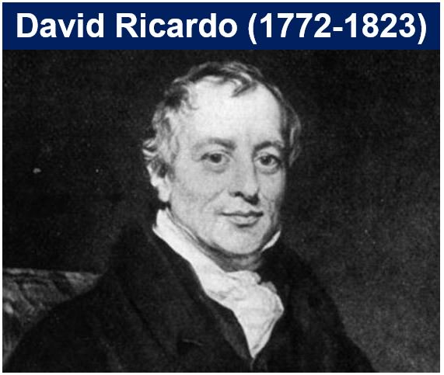According ____________________________________, a famous economist and financier, the advantage of international trade is that countries can produce the goods and services that they can make most efficiently. In turn, they can buy goods and services from other countries.
* This __________________________________ makes the __________________ use of resources across global borders.
* Over the last 100 years, the patterns of world trade have changed significantly. Countries are now exchanging goods and services with each other to a much greater extent.
* **Why do you think patterns of world trade have been changing?**

**____________________________________________________________________________________________________________________________________________________________________________________________________________________________________________________________**

* **What are some examples of improvements in technology and transport?**

**____________________________________________________________________________________________________________________________________________________________________________________________________________________________________________________________**

**Important to note:**

**____________________________________________________________________________________________________________________________________________________________________________________________________________________________________________________________________________________________________________________________________________________________________________________________________________________________________**

**Watch the video and list 3 facts that you observed.**

* **____________________________________________________________________________**
* **____________________________________________________________________________**
* **____________________________________________________________________________**

|  |  |
| --- | --- |
| **International Trade** | |
| **Positives** | **Negatives** |
|  |  |

* Traditionally Australia traded with the U_____________ K_____________ and E_______________, selling goods and services such as A__________________ goods and N________________ resources.
* After the Second World War Australia increased it’s trade with the U________________ S____________________.
* In the 1970s Australia began trading with countries such as J_____________, H_____________ K____________ and S__________________.
* This was followed by T____________, S__________ K___________ and C__________ in the 1980s.
* Although Australia still exports to the UK and Europe, most of Australia’s exports are now purchased by countries in our own region.
* **Why do you think Australia’s direction of trade has changed?**

**____________________________________________________________________________________________________________________________________________________________________________________________________________________________________________________________**